FACTORIAL WITHOUT RECURSION:

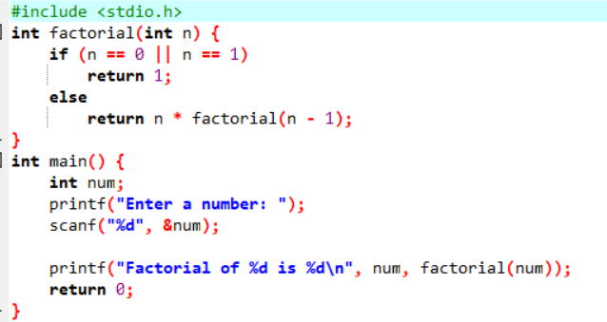

OUTPUT:

